
MAHARASHTRA STATE BOARD OF TECHNICAL
EDUCATION, MUMBAI
A Project Report on
Ganesh Crane Service Management System
Submitted as a partial fulfillment for the award of
Diploma in Computer Engineering

Submitted by

Sachin Pravin Patil Piyush Deepak Khalane Yash Jaysing Jadhav
Prathamesh Nishikant Joshi



A Project Report on
Ganesh Crane Service Management System
Submitted as a partial fulfillment for the award of
Diploma in Computer Engineering

Submitted by

Sachin Pravin Patil 23610960258
Piyush Deepak Khalane 23610960271
Yash Jaysing Jadhav 24610960303
Prathamesh Nishikant Joshi 24610960304

Guided by.
Ms. P. S. Sonawane




MAHARASHTRA STATE BOARD OF TECHNICAL EDUCATION, MUMBAI
S.S.V.P.S's Bapusaheb Shivajirao Deore Polytechnic, Dhule
DEPARTMET OF COMPUTER ENGINEERING
CERTIFICATE
This is to certify that,

Sr.  No. | Roll No. | Name | Enrollment Number | Exam Seat number
1 | 74 | Patil Sachin Pravin | 23610960258 | 405637
2 | 82 | Khalane Piyush Deepak | 23610960271 | 405645
3 | 113 | Jadhav Yash Jaysing | 24610960303 | 405676
4 | 114 | Joshi Prathamesh Nishikant | 24610960304 | 405677
has satisfactorily completed project entitled “Ganesh Crane Service Management System” in partial fulfillment for the Diploma Course in Computer Engineering of the Maharashtra State Board of Technical Education at our polytechnic during the academic year 2025-2026. The project is completed by a group consisting of four persons under the guidance of the Faculty Guide. Date :

Place: Dhule

Signature: Signature:
Name : Ms. P. S. Sonawane Name :
Faculty Guide External Examiner

Signature: Signature:
Name : Mr. N. D. Patel Name : Mr. S. A. Hire
H.O.D. Principal.

GANESH CRANE SERVICE
National Highway,no.3,Chalisgaon Road, Chaufully, Dhule, Maharashtra 424311
Phone: +919604126814 | Email:Rakeshcraneservice7@gmail.com

To Whomsoever It May Concern

This is to certify that, following students of Final Year of Diploma in Computer Engineering from S.S.V.P.S's B. S. Deore Polytechnic, Dhule have completed their Capstone Projects having title "Ganesh Crane Service Management System".
Name of Student

- Sachin Pravin Patil

- Piyush Deepak Khalane

- Yash Jaysing Jadhav

- Prathamesh Nishikant Joshi

This project was sponsored by us and is developed as per our requirements. We appreciate their honest efforts, sincerity and hard work.
We wish them all the best and bright future.

For, GANESH CRANE SERVICE
National Highway,no.3,Chalisgaon Road, Chaufully, Dhule, Maharashtra 424311
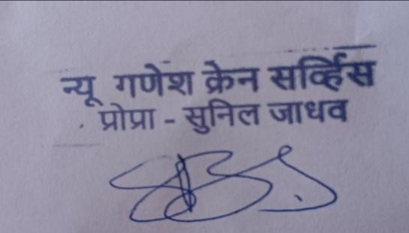

Abstract
The proposed system “Ganesh Crane Service Management System” is designed to
manage crane booking, and income management efficiently.

In the traditional system, crane service providers manage bookings, customer details, and payments manually, which is time-consuming and error-prone. This system provides a digital platform where users can book cranes online, track their orders, and contact the service provider easily.
The application also helps the owner to track total income, manage orders, and maintain records of different types of cranes such as Hydra, Mobile, Tower, and other heavy cranes.
The system is developedusing HTML, CSS, JavaScript, React.js, node.js and MangoDB, making it user-friendly and efficient for both customers and crane service providers.

List of figures

Fig No. | Title of figure | Page No.
2.1 | Manual Record of Crane Bookings | 7
2.2 | Manual Record of Expenses | 8
5.1 | System Diagram | 26
5.2 | Use Case Diagram | 29
5.3 | Class Diagram | 31
5.4 | ER Diagram | 32
6.1 | Home Dashboard Interface | 37
6.2 | Crane Fleet Interface | 38
6.3 | Contact Page Interface | 39
6.4 | Milestone & Achievement Interface | 41
6.5 | Footer Interface | 42
6.6 | About page Interface | 44
6.7 | Service Section Interface | 45
6.8 | Crane Booking Interface | 46
6.9 | User Booking Interface | 48
6.10 | Admin Login Interface | 50
6.11 | Admin Dashboard Interface | 51
6.12 | Payment Page Interface | 52
6.13 | Payment Success Interface | 53
6.14 | All Booking Interface | 54
6.15 | Payment Record Interface | 56
7.1 | Login Module Test Summary | 7.1

List of tables

Table No. | Title of table | Page No.
1.1 | Crane Types & Uses | 2,3
2.1 | Methods and Resources of Crane management | 11
2.2 | Common and Specific Resources for Crane Services | 11,12
7.1 | Teat Plan | 58,59
7.2 | Execution for Login | 60,61
7.3 | Defect Report for Login | 64,65

Chapter 1 Introduction
The crane service industry plays a significant role in construction, infrastructure development, and heavy material handling operations. Cranes are essential equipment used for lifting, loading, unloading, and transporting heavy materials across various industrial and construction sites. Efficient management of these operations is necessary to ensure smooth workflow, safety, and timely completion of tasks.

Crane service operations involve multiple activities such as booking requests, allocation of cranes, tracking of ongoing work, and maintaining financial records. These activities require proper coordination and management to handle multiple clients and service requests effectively.

In traditional systems, most of these operations are carried out manually. Service providers maintain booking records, customer details, and financial transactions using registers or basic tools. This approach is time-consuming, error-prone, and lacks proper organization. Managing multiple bookings and tracking their status becomes difficult, leading to inefficiencies in service delivery.

To address these challenges, a structured and automated system is required. Such a system helps in organizing service operations, maintaining records systematically, and improving overall efficiency. It enables proper handling of booking processes, tracking of service status, and management of financial data in a centralized manner.

The system is designed to support various crane operations by maintaining details of different crane types and their usage. It allows efficient management of service requests, monitoring of ongoing and completed tasks, and recording of financial transactions associated with the services.

By providing a systematic approach to manage crane services, the system improves accuracy, reduces manual effort, and enhances operational efficiency. It also helps in better decision-making by maintaining organized records and providing structured data for analysis.

Overall, the system aims to automate crane service operations, reduce manual effort, improve accuracy, and enhance service quality for both service providers and customers.

Table 1.1 Crane Types & Uses

Crane Types | Description & Uses
1.Tower Crane | It is a fixed crane used in tall buildings. It is mainly used in high-rise construction projects.
2. Truck Mounted Crane | It is mounted on a truck chassis. It is used for quick lifting and transportation work.
3. Mobile Crane | It is a crane mounted on a truck or vehicle. It is used for transporting and lifting heavy materials from one place to another.
4. All Terrain Crane | It can operate on all types of roads and surfaces. It is used in large construction and highway projects.
5. Crawler Crane | It is a crane with tracks instead of wheels. It is used for heavy lifting on rough and uneven surfaces.
6. Hydra Crane | It is a small mobile crane with a hydraulic system. It is mainly  used for loading and unloading materials and small construction work.
7. Rough Terrain Crane | It is specially designed for off-road conditions. It is used at construction sites with uneven ground.
8.Floating Crane | It is installed on a boat or barge. It is used in marine and port operations.
9.Overhead Crane | It is a fixed crane used inside factories. It is used for material handling in industries.

Crane Types | Description & Uses
10.Gantry Crane | Used in shipyards, warehouses, and construction sites for lifting heavy materials and containers.
11.Jib crane | Uses: Used in workshops, factories, and warehouses for lifting and moving materials within a limited range.
12.Carry Deck Crane | Uses: Used in industrial plants, construction sites, and for material handling in tight spaces.
13.Magnetic Crane | Uses: Used in scrap yards, steel plants, and recycling industries for lifting metal objects.
14.Telescopic Crane | It has an extendable boom. It is used for lifting materials at different heights.

The different types of cranes listed above are designed to perform specific tasks based on the nature of work, load requirements, and working conditions. Each crane type has unique features that make it suitable for particular operations such as construction, material handling, transportation, and industrial work. The selection of an appropriate crane plays an important role in ensuring efficiency, safety, and timely completion of tasks.

Mobile and hydra cranes are commonly used for general lifting and transportation purposes due to their flexibility and easy movement. Tower cranes are essential for high-rise construction projects where heavy materials need to be lifted to greater heights. Similarly, crawler and rough terrain cranes are suitable for working in uneven and challenging environments, where stability and strength are required.

In addition, specialized cranes such as overhead cranes and floating cranes are used in industries and marine operations respectively. The proper utilization of different crane types helps in improving operational performance, reducing manual effort, and enhancing productivity. Therefore, understanding the characteristics and uses of various cranes is essential for effective crane service management.

Chapter 2 Literature Survey
We visited a crane service provider located at Mohadi, Dhule district, which operates along National Highway No. 3. The service provides various types of cranes used for construction, transportation, and heavy lifting purposes.

The crane service is known for handling different types of lifting operations such as loading and unloading materials, construction work, and heavy equipment transportation. These services are essential for industrial and infrastructure development activities.

During the study, we interacted with the crane service provider to understand how the current system operates.

While discussing, the following questions we asked and we get this answers:-

Q1. Can multiple cranes be managed at the same time?
Ans 1. Multiple cranes can be managed simultaneously depending on demand.

Q2. Are cranes deployed at different locations?
Ans 2. Cranes are deployed at different locations based on customer requirements.

Q3. How are multiple bookings managed and remembered?
Ans 3. Bookings are remembered and managed manually using registers or phone records.

Q4. What factors influence the selection of cranes for a particular task? Ans 4. Crane selection depends on load type, weight, and work location.

Q5. How does the usage of cranes vary based on type of work and location?
Ans 5. Crane usage varies based on construction work, transportation, and lifting requirements.

Q6. What are the typical expenses involved in crane services?
Ans 6. Expenses include fuel, maintenance, operator charges, and transportation costs.

Q7. How are bookings and orders recorded?
Ans 7. Bookings and orders are recorded manually.

Q8. How do customers contact the service provider?
Ans 8. Customers contact the service provider through phone calls or direct visits.

Q9. How are payments recorded?
Ans 9. Payments are recorded manually in registers.

Q10. Is there any system to track ongoing and completed work?
Ans 10. There is no proper system to track ongoing or completed work.

Q11. What is the method of maintaining records?
Ans 11. All records are maintained manually, which may lead to errors.

For every crane service provided, various activities are performed such as booking, crane allocation, transportation, execution of work, and payment handling. These activities are essential for completing service requests efficiently.

The crane service provider manages multiple cranes at different locations, and each crane is used for different types of operations. The selection of crane depends on the nature of work and load requirements.

Income is generated from providing crane services for construction, material handling, and transportation activities. Expenses are incurred on fuel, maintenance, operator wages, and repair activities. These income and expenses are recorded manually.

We collected information about different types of cranes used, their applications, and the working conditions in which they operate. We also gathered details about the booking process, order handling, and financial transactions.

We analysed that all records related to bookings, income, and expenses are maintained manually, which makes it difficult to manage data efficiently. There is no proper system to organize, track, and analyse crane service operations.

An example of manual booking record maintained by the service provider is shown in Fig 2.1.

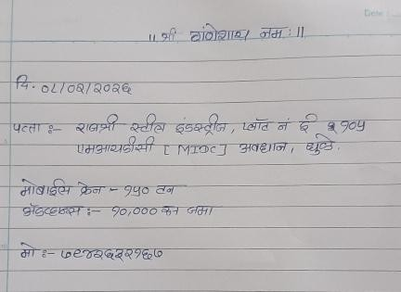
Contact Details
Payment Details
Job Address
Crane Type
Booking Date

Fig 2.1 Manual Record of Crane Booking

This manual record describes:
- Customer details
- Date of booking
- Type of crane used
- Location of work
- Charges for service

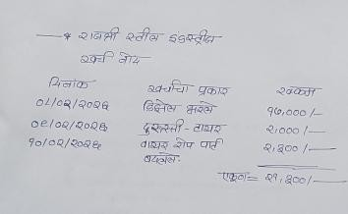
An example of manual expense record maintained by the service provider is shown in Fig 2.2.
Working Dates
Types Of Expenses
Total Cost
Per Day Expenses Cost
Indrustry Name

Fig 2.2 Manual Record of Expenses The above manually recorded expenses describe:
- Fuel expenses
- Maintenance and repair costs
- Working Dates
- Industry Name
- Total cost of expenses
- Combined record of multiple services

Income sources and expenses from crane service:

Income from Crane Services:

- Crane Booking Charges
- Hourly / Daily Rental Charges
- Transportation Charges
- Heavy Lifting Service Charges
- Equipment Rental
- Emergency Service Charges
- Contract-based Work

Expenses on Crane Service Activities:

- Fuel Charges (Diesel/Petrol)
- Operator Wages
- Maintenance and Repair
- Spare Parts and Lubricants
- Transportation Costs
- Insurance Charges
- Loan/EMI for Cranes
- Electricity and Workshop Expenses

Crane service providers generate income from multiple sources such as crane bookings, rental services, transportation, and heavy lifting operations. The income mainly depends on the type of crane used, duration of work, and nature of the task performed.

On the other hand, various expenses are incurred in order to maintain and operate crane services. These include fuel costs, operator wages, maintenance and repair expenses, and other operational costs. Regular servicing and proper maintenance are necessary to ensure the smooth functioning of cranes.

Sometimes, expenses may exceed income due to factors such as high maintenance costs, low demand, or unexpected breakdowns.

Therefore, effective management of income and expenses is essential for the financial stability of the crane service business. Proper planning and budgeting help in maintaining profitability and long-term sustainability.

Expenses for Business / Personal Activities:
- Office Expenses
- Electricity Bill
- Staff Salary
- Communication Charges (Mobile/Internet)
- Travel and Transportation
- Medical Expenses
- Personal Expenses
- Repair and Maintenance

In addition to operational expenses, the crane service provider also incurs business and personal expenses. Managing both service-related and personal expenses is important for maintaining overall financial balance.

Separating operational expenses from personal expenses helps in better understanding of financial performance. It also assists in making informed decisions for improving business efficiency and reducing unnecessary costs.

Crane service expenses are associated with various activities such as booking management, crane operation, transportation, and maintenance. Each activity requires proper resources, equipment, and workforce for effective execution.

The following tables outline is the operational methods, necessary resources, and specialized equipment required to manage crane service requests, maintenance, and onsite execution.

Table 2.1 Methods and Resources of Crane management

Methods | Resources/Materials
Site Inspection | Service Manager, Measuring Tape, Site Safety Checklist
Crane Selection | Technical Manuals, Load Charts, Capacity Assessment tools
Logistics and Transport | Heavy-Duty Trailers, Fuel, Route Permits
Onsite Setup | Rigging Crew, steel Plates, Leveling Tools
Maintenance & Repair | Mechanics, Spare Parts, Lubricants
Safety Audits | Inspection Logs, Safety Officer, PPE
Billing & Documentation | Logbooks, Invoicing Software, Work Completion Certificates

There are various resources common to all service stages, while specific tools are required for specialized lifting or maintenance activities. These are categorized in Table 2.2 below.

Table 2.2 Common and Specific Resources for Crane Services

Common Resources | Specific Resources
Skilled Labor (Operator/Helper) | Hydraulic Jacks
Service vehicles | Wire Rope, Chains
Fuel and Lubricants | Telescopic Jibs
Communication devices | Counter Weight
Standard PPE | Anti-Twp Block Sensors

Common Resources | Specific Resources
Safety Equipment | Helmet, Gloves, Safety shoes
Maintenance Tools | Spanners, Tool Kits
Power supply | Generators
Site Inspection team | Survey Instrument

  - Study of existing system

Through this literature survey, we explored various resources related to service management systems and equipment rental platforms. These materials provide comprehensive guidance and practical information on managing service-based operations efficiently. Our study has equipped us with valuable knowledge to effectively manage bookings, resources, and financial transactions related to crane services.

We studied concepts from service management and business operation systems which provide a holistic perspective of managing technical services. These studies helped us understand how to design a system that handles customer requests, crane allocation, operator management, and billing processes in an organized manner.

Ganesh Crane Service Management System Module:
Service Management and Operations emphasizes the importance of managing crane services efficiently to generate sufficient income and ensure customer satisfaction

Service Planning:
Service planning helps the business move towards higher productivity and profitability by efficiently utilizing available resources such as cranes, operators, and time schedules.

- In this process, the system considers different types of services like:
- Heavy lifting services (construction cranes, industrial lifting, material handling)
- Transport-based services (loading/unloading, shifting heavy equipment)
- Specialized crane services (hydraulic cranes, mobile cranes, tower cranes)
- Emergency/on-demand services (urgent lifting requirements, breakdown assistance)

The system also manages different booking scenarios such as:
- Advance Booking – Customers schedule crane services in advance
- Instant Booking – Customers request immediate crane services

Limitations of existing system

The current manual system used in crane service management has several limitations that affect efficiency, accuracy, and decision-making.

Record Keeping Issues:
      - All records such as booking details, customer information, income, and expenses are maintained manually in registers or basic files.
      - Booking, crane usage, and financial records are often mixed together, making it difficult to analyze specific data.
      - Lack of proper categorization (booking, operator, crane, expenses) creates confusion.
      - Difficult to maintain records based on different locations where cranes are used.

Human Errors:
      - Manual entry can lead to mistakes in booking details, billing, and calculations.
      - Missing or incomplete records are common due to improper documentation.
      - Errors in data can affect service quality and financial accuracy.

Time-Consuming Process:
      - Managing bookings, assigning cranes, and recording transactions manually takes a lot of time.
      - Searching for specific records or past data is slow and inefficient.
      - Generating reports manually is difficult and time-consuming.

Inefficient Resource Management:
      - No proper system to track crane availability in real-time.
      - Operator assignment is done manually without proper planning.
      - Leads to underutilization or overuse of resources.

Lack of Data Security:
      - Physical records can be lost, damaged, or misplaced.
      - No backup system for important data.
      - Sensitive business information is not secure.

Lack of Analysis and Reporting:
      - Manual system does not support proper data analysis.
      - Difficult to generate reports like daily/monthly bookings, income, and expenses.
      - No proper insights for decision-making and business growth.

Poor Communication and Transparency:
      - Communication between client, admin, and operator is not well coordinated.
      - No real-time updates on booking status.
      - Leads to confusion, delays, and customer dissatisfaction.

Problems related to Operator Management
      - Operators are assigned manually without checking availability.
      - No proper tracking of operator work status (free, busy, assigned).
      - Communication gap between admin and operator causes delays.
      - No history of operator performance or completed work.

Problems related to Crane Allocation
- Crane allocation is done manually, which is time-consuming.
- Difficult to manage multiple cranes at different locations.
- No system to track crane usage and availability.
- Improper allocation may lead to delays in service.

Problems related to Financial Management (Income & Expenses)
      - Difficult to maintain accurate records of income from crane services.
      - Expenses such as fuel, maintenance, operator salary, and repairs are not tracked properly.
      - No categorization of income and expenses.
      - Unable to generate reports for specific periods
      - (daily/monthly/yearly).

Problems related to Status Tracking and Reporting
      - No real-time tracking of job status (pending, accepted, in-progress, completed).
      - Lack of transparency between client, admin, and operator.
      - Difficult to generate reports based on historical data.
      - Poor decision-making due to lack of proper data analysis.

Overall System Problems
      - Manual system leads to data loss and errors.
      - Time-consuming and inefficient process.
      - Lack of centralized system to manage all activities.
      - Poor communication and coordination between users.

Problem Definition
To develop a web-based Ganesh Crane Service Management System that will automate and simplify the management of crane services.

The system will focus on:
      - Managing crane booking and service requests
      - Managing operator assignment and crane allocation
      - Maintaining income and expense records

System will provide:
      - Easy and structured booking system for clients
      - Proper management of crane and operator availability
      - Detailed categorization of income and expenses
      - Real-time status tracking of services
      - Generation of reports (booking, income, expenses, performance)

Outcome:
This system will help improve efficiency, reduce manual work, and support better decision-making by providing accurate data, ultimately increasing productivity and profitability of the crane service business.

Motivation

We also studied about an application that helps in managing crane services efficiently. Ganesh Crane Service Management System is developed by taking inspiration from the Crane Finder application. This system is designed to simplify and digitize crane service operations.

This system:
- Records client, operator, and admin details.
- Provides facility to manage crane bookings and service requests.
- Helps to maintain records of income and expenses related to crane services.
- Generates reports that provide useful information about crane usage, bookings, and financial transactions.
- Enables users to track service history, payments, and operational data efficiently.

Chapter 3 Scope of the Project

Scope of the project
The Ganesh Crane Service Management System, is designed to simplify and improve the process of booking, managing, and tracking crane services. In the existing system, crane service operations are mostly handled manually, which leads to problems such as miscommunication, data loss, difficulty in tracking service requests, and delays in service delivery. The scope of this project focuses on overcoming these limitations by providing a digital, efficient, and user- friendly solution.

The application aims to provide a centralized platform where customers can request crane services online, and administrators can manage crane availability, service requests, and operations effectively. This system will help both customers and service providers by maintaining accurate records and improving overall efficiency.

The scope of the project includes managing all aspects of crane services, starting from customer registration to booking cranes, tracking service status, and maintaining service history. The system ensures that all data is securely stored and can be accessed whenever required.

Key Functional Areas of the System
The scope of this project is divided into several functional modules which help in efficient management of the system.

Customer Registration and Management
  - The system allows users to register customer details such as name, contact information, address, and company details (if any).
  - Each customer will have a unique record in the system.
  - This helps in maintaining organized and structured data.
  - The system allows updating and viewing customer details anytime.

Crane and Equipment Management
  - The system maintains details of all cranes including type, capacity, registration number, and current status (available/on hire/under maintenance).

  - It helps in tracking crane availability in real time.
  - The system ensures that only available cranes are shown for booking.
  - It reduces confusion and double-booking of cranes.

Booking and Service Request Management
  - The system stores detailed booking records such as customer name, crane used, hire date, duration, location, and operator details.
  - It allows adding, updating, and viewing booking records.
  - All records are stored digitally, reducing dependency on paper.
  - It helps in maintaining complete service history for each customer and crane.

Reminder and Notification System
  - The system provides reminders for upcoming or pending service bookings.
  - Notifications help customers and admins take timely action.
  - This feature ensures no service request is missed or delayed.
  - It improves operational efficiency.

Admin and Operator Management
  - Operators can update service status (started, completed, delayed) after each job.
  - Admin can manage the entire system including users, cranes, bookings, and reports.
  - The system allows easy access to service records for authorized staff.
  - It reduces workload and improves coordination.

Data Storage and Security
  - All data is stored in a centralized database.
  - It ensures data safety and reduces chances of data loss.
  - Secure login system protects user information.
  - Data can be accessed from anywhere when required.

Report Generation
  - The system generates detailed reports of crane usage, customer history, and completed/pending bookings.
  - Reports help in tracking service performance and revenue.
  - Admins and operators can easily analyze the data.
  - It supports better decision-making in crane service management.

Benefits of the Proposed System
      - Reduces manual work and paperwork
      - Improves accuracy of records
      - Provides timely reminders for bookings
      - Ensures proper tracking of crane availability and service status
      - Saves time for customers and service providers
      - Enhances overall crane service management

Future Scope of the Project
The system can be further enhanced with additional features such as:
      - Mobile application for easy access
      - SMS and email notification system
      - Multi-language support for different regions
      - Integration with GPS for live crane tracking
      - Cloud-based storage for better accessibility

Chapter 4 Methodology

Requirements Gathering and Analysis
For the Ganesh Crane Service Management System, we utilized the Waterfall model as the development approach. The Waterfall model is a sequential software development process, where progress flows through defined phases step by step.

Phase 1: Requirements Gathering and Analysis
During this phase, we focused on understanding the requirements of crane service operations such as booking management, crane allocation, order tracking, and financial management.

Customer Requirements:
      - The system should accept customer details.
      - The system should store and manage customer information for booking and communication purposes.

Crane Requirements:
      - The system should accept details of different types of cranes.
      - The system should store information of various cranes such as Hydra, Mobile, Tower, etc.
      - The system should manage crane availability and usage details.

Booking Requirements:
      - The system should accept booking details from customers.
      - The system should record booking information such as date, location, crane type, and work details.
      - The system should allow tracking of booking status such as pending, accepted, rejected, in-progress, and completed.

Income Requirements:
      - The system should accept income details from various crane services.

      - The system should record income based on different categories such as booking charges, rental charges, and transportation charges.
      - The system should provide detailed income reports.
      - The system should generate income reports based on specific time periods (month/year).

Expense Requirements:
      - The system should accept and record expenses related to crane operations.
      - The system should categorize expenses such as fuel, maintenance, operator wages, and repair costs.
      - The system should provide detailed expense reports.
      - The system should generate expense reports based on specific dates.
      - The system should help in analysing expenses and improving overall profitability.

System Requirements
  - Operating System: Windows 11
  - Platform: Visual Studio Code
  - Languages: HTML / React, CSS, JavaScript, Node.js
  - Database: MangoDB

Hardware Requirements
  - Processor: Intel i7
  - RAM: Minimum 4 GB
  - Hard Disk: 500 GB or more

Phase 2: System Design
- In this phase, the system architecture, database structure, and user interface were designed.
- Database design includes tables for customers, cranes, bookings, and payment records
- User interface is designed for easy navigation and user-friendly interaction system modules are clearly defined

Phase 3: Implementation
In this phase, the system is developed using:
- Frontend: HTML, CSS, JavaScript, React
- Backend: Node.js

- Database: MongoDB

All modules such as customer management, crane booking, order tracking are implemented.

Phase 4: Testing
- Testing is performed to ensure the system works correctly.
- Unit Testing – testing individual modules
- Integration Testing – testing combined modules
- System Testing – testing the complete system
- Errors and bugs are identified and fixed.

Phase 5: Deployment
- The system is deployed on a server
- Users can access the system through a web browser
- The system becomes ready for real-time use

Phase 6: Maintenance
- Regular updates are performed
- Bugs are fixed if found
- System performance is improved over time

Chapter 5:
Details of designs, working and processes

For the Ganesh Crane Service Management System, the System Design phase involved creating a structured architecture, database design, and user interface based on the requirements gathered from the crane service operations.

In this phase, the system requirements were transformed into a detailed design that defines the overall structure, components, and functionalities of the application.

Firstly, the database schema was designed to efficiently store information related to crane bookings, customer details, crane types, and financial records.

The necessary data entities were identified such as customer details, crane details (e.g., Hydra, Mobile, Tower cranes), booking information, payment records, and service details. These entities help in organizing and managing the complete workflow of crane service operations.

Based on the identified requirements, the core functionalities of the system were defined as follows:

- Customer Management
- Crane Management
- Booking Management
- Order Tracking
- Payment Management
- Report Generation

System Diagram

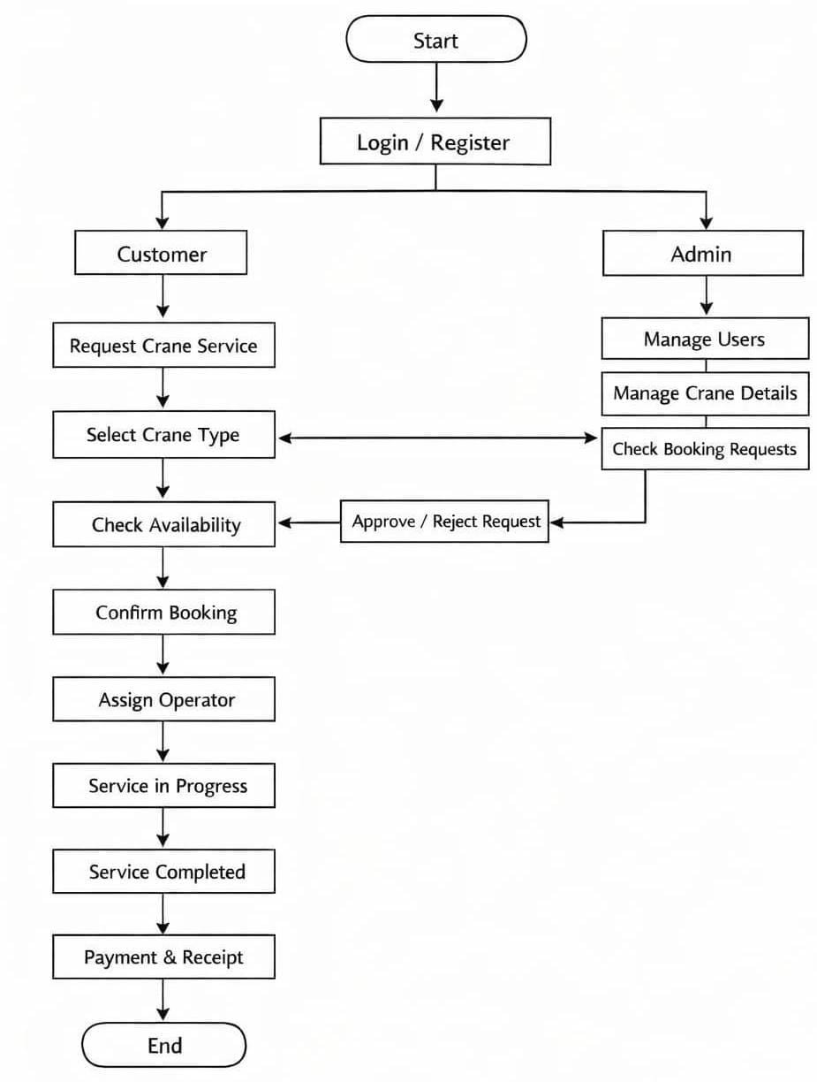

Fig.5.1 System Diagram

The above figure represents the overall working of the Ganesh Crane Service Management System, which mainly involves two primary users: Customer and Admin. The system is designed to ensure smooth communication, efficient crane booking, and proper service management.

Initially, the process starts with the customer. The customer registers into the system, logs in, and requests a crane service by providing necessary details such as date, location, and crane type. The customer can also check crane availability before confirming the booking.

Once the booking request is submitted, it is received by the admin. The admin checks the booking request, verifies crane availability and operator availability, and then decides whether to accept or reject the request. If the request is accepted, the admin assigns a suitable crane and operator for the job.

After the assignment, the service process begins. The crane service is carried out at the specified location, and the status is updated as “Service in Progress.” Once the work is completed, the status is updated to “Service Completed.”

After completion of the service, the payment process is carried out. The customer makes the payment through cash or online mode, and a receipt is generated for the transaction.

The admin plays an important role in managing the entire system. The admin is responsible for managing users, maintaining crane details, handling booking requests, assigning operators, monitoring service status, and generating reports related to bookings, income, and overall system performance.

Step-wise Working of System
- Customer registers and logs into the system
- Customer requests crane service
- Customer selects crane type
- Customer checks crane availability
- Customer confirms booking request
- Admin receives booking request
- Admin checks crane and operator availability
- Admin accepts or rejects the request
- If accepted, crane and operator are assigned
- Service starts (Work in Progress)
- Service is completed
- Payment is processed (Cash/Online)
- Receipt is generated
- Admin monitors system and generates reports

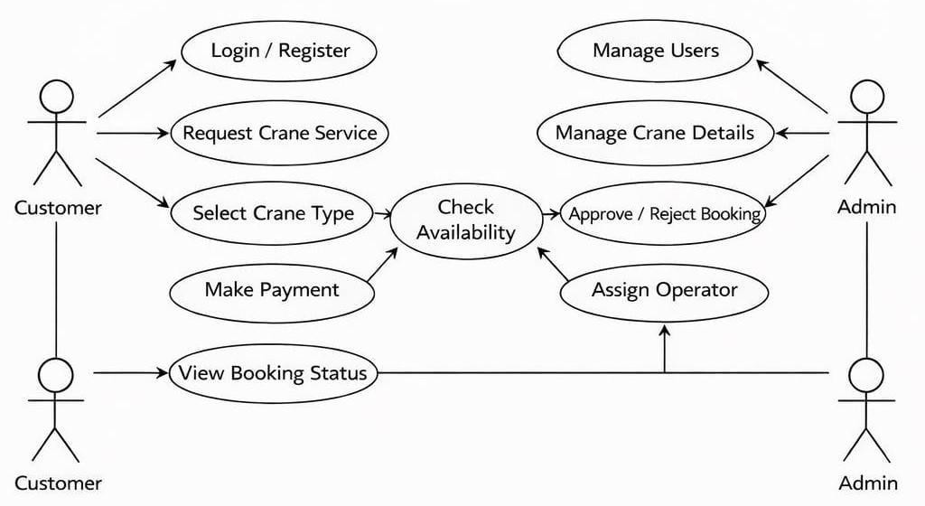

Fig.5.2 Use case Diagram

Actors:
  - Customer: Represents the user who wants to book crane services.
  - Admin: Manages the entire system (users, cranes, bookings, etc.).
  - System: Refers to the Ganesh Crane Service Management application.

Use Cases:
Authentication:
  - Register: The customer can create a new account.
  - Login: The customer/admin can log in to the system.
  - Verification: The system verifies user credentials.
  - Crane Booking Activities (Customer Side):
  - Request Crane Service: Customer sends a request for crane service.
  - Select Crane Type: Customer selects required crane (e.g., Hydraulic, Mobile Crane).
  - Check Availability: System checks crane availability based on date/location.

  - Make Payment: Customer can pay online or offline.
  - View Booking Status: Customer tracks booking (Pending / Approved / Rejected / Completed).

Admin Management Activities:
  - Manage Users: Admin can add, update, or delete users.
  - Manage Crane Details: Admin can add/update crane information (type, capacity, availability).
  - Approve / Reject Booking: Admin reviews and approves or rejects requests.
  - Assign Operator: Admin assigns crane operator to approved bookings.
  - Update Crane Status: Admin updates crane status (Available / Unavailable).

System Operations:
  - Send Notifications: System notifies customer about booking status.
  - Generate Reports: Admin can view reports (bookings, payments, usage).
  - Maintain Booking Records: System stores all booking and transaction data.

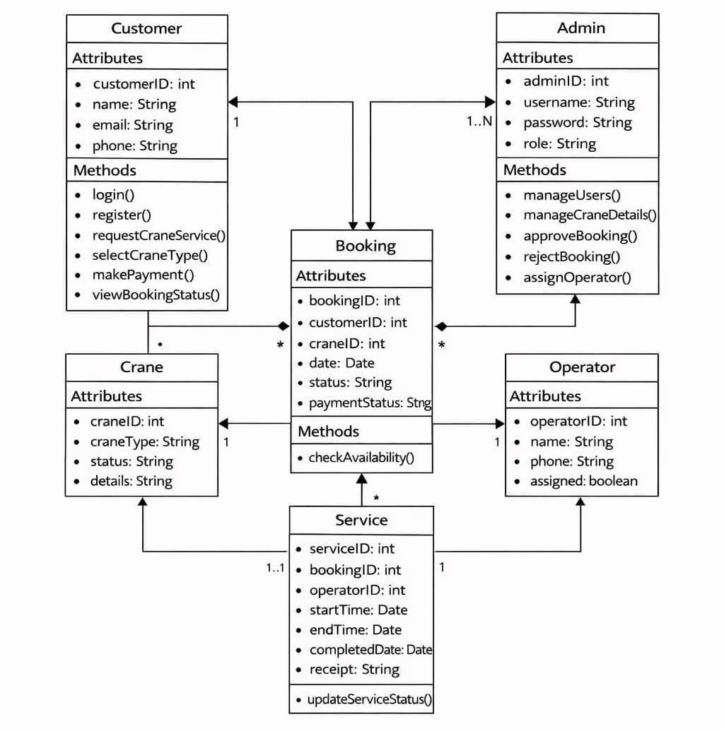

Fig.5.3 Class Diagram

This is a UML class diagram for the Ganesh Crane Service Management System. Customer: Registers, logs in, selects crane type, makes payment, and views bookings. Admin: Manages users, cranes, bookings, and operators (approve/reject bookings).
Booking: Central class that connects Customer, Crane, and Operator. It stores booking details like date, status, and payment.

Crane: Contains crane details (type, status, etc.) and is assigned to bookings.

Operator: Assigned to cranes and bookings to perform the work. Service: Tracks the actual work (start time, end time, completion, receipt)

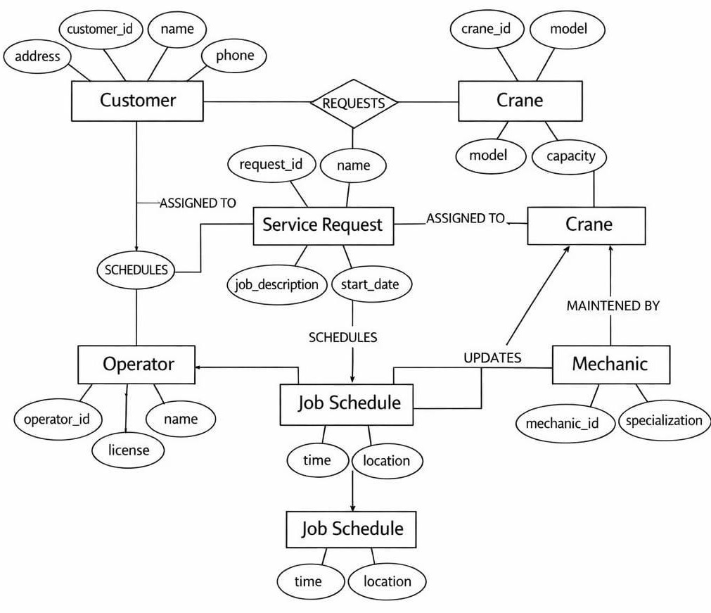

Fig. 5.4 ER Diagram

These are the main components of the system:

- Customer
Attributes: customer_id, name, address, phone
Role: Customer requests crane services.

Crane
Attributes: crane_id, model, capacity
Role: Crane is used to perform the requested job.

Service Request
Attributes: request_id, name, job_description, start_date
Role: Represents the service requested by the customer.

Operator
Attributes: operator_id, name, license
Role: Operates the crane.

Mechanic
Attributes: mechanic_id, specialization
Role: Maintains and repairs cranes.

- Job Schedule Attributes: time, location
Role: Stores scheduling details of the job.

Relationships (Connections)

- Customer → Requests → Crane
Customer sends a request for a crane.

- Customer → Assigned To → Service Request
Each request is linked to a customer.

- Service Request → Assigned To → Crane
The system assigns a crane for the job.

- Operator → Schedules → Service Request
Operator manages and schedules the service.

- Operator → Job Schedule
Operator creates job schedule (time & location).

- Mechanic → Maintained By → Crane
Mechanic is responsible for crane maintenance.

- Mechanic → Updates → Job Schedule
Mechanic Can update schedule if needed (e.g- repair delay)

Chapter 6: Results and Applications

The Ganesh Crane Service Management System has been successfully developed and implemented as a web-based application to manage crane booking and service operations efficiently. The system provides a digital platform for customers, operators, staff, and administrators to interact and manage crane-related activities in a structured and organized manner.
The application is developed using HTML, CSS, JavaScript, React, and Node.js, with a backend database managed using MongoDB. The system ensures easy accessibility, secure data handling, and efficient management of crane service operations.

Customer Module Results
The customer module allows users to manage crane service requests effectively.
  - Customers can register and login into the system
  - They can request crane services based on their requirements
  - View booking details and service history
  - Track booking status
  - Receive notifications and updates
This module helps customers to easily book crane services without delays and ensures proper tracking of service requests.

Operator Module Results
  - The operator module improves crane operation management and efficiency.
  - Operators can view assigned tasks and booking details
  - Update job status after completion
  - Provide service reports and notes
  - Monitor assigned work progress
This reduces manual communication and improves accuracy in service execution.

Staff Module Results
The staff module helps in managing operational tasks efficiently.
  - Manage booking requests and scheduling

  - Handle customer inquiries
  - Maintain crane availability details
  - Send notifications to customers
This ensures smooth workflow and coordination between different users.

Admin Module Results
The admin module provides complete control over the system.
  - Manage customers, operators, and staff
  - Monitor system activities
  - Maintain database records
  - Generate reports
Admin ensures the proper functioning and security of the system.

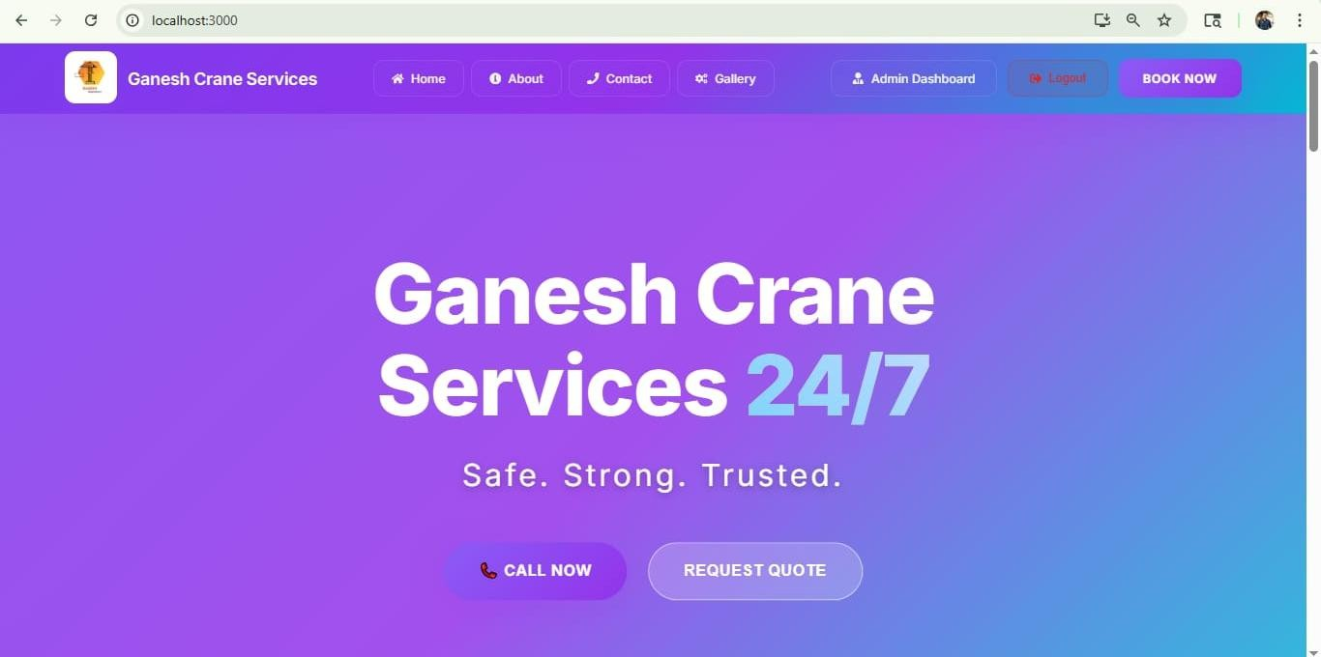

Fig 6.1 Home Dashboard Interface

The above diagram represents the Home Dashboard of the Ganesh Crane Service Management System. It provides a user-friendly and attractive interface for customers to easily access crane services and interact with the system efficiently. The dashboard is designed to ensure smooth navigation and quick access to important features.

At the top of the interface, a navigation bar is provided which includes options such as Home, About, Contact, Gallery, Admin Dashboard, and Logout. It also includes a “Book Now” button that allows users to quickly proceed with crane booking. This navigation menu helps users to easily move between different sections of the system.

The main section of the dashboard displays the title “Ganesh Crane Services 24/7” along with a tagline “Safe. Strong. Trusted.”, which highlights the reliability and availability of the service. This section is designed to attract users and clearly communicate the purpose of the system.

Below the main heading, action buttons like “Call Now” and “Request Quote” are provided.
These options allow users to directly contact the service provider or request pricing information

for crane services, making the system more interactive and user-friendly.

Overall, this interface helps customers to quickly understand the services offered, easily navigate through the system, and perform important actions such as booking a crane, contacting the provider, and accessing additional information. The design ensures better user experience and efficient service management.

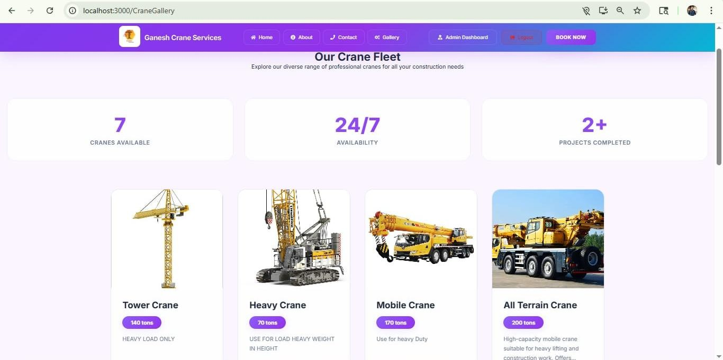

Fig 6.2 Crane Fleet Interface

The above diagram represents the Crane Gallery section of the Ganesh Crane Service Management System. This interface provides a clear and organized view of the different types of cranes available for booking. It helps users to easily explore crane options and select the most
suitable one based on their requirements.

At the top of the interface, a navigation bar is available with options such as Home, About, Contact, Gallery, Admin Dashboard, and Logout, along with a “Book Now” button. This allows users to quickly navigate through the system and access booking features.

The main section displays the heading “Our Crane Fleet”, which introduces the available crane services. Below this, summary cards are shown, providing key information such as number of cranes available, 24/7 availability, and completed projects. These details highlight the reliability and efficiency of the service.

Further, the interface shows different crane types in a card format. Each card includes:
- Crane Image
- Crane Name (e.g., Tower Crane, Heavy Crane, Mobile Crane, All Terrain Crane)
- Lifting Capacity (in tons)
- Short description of usage
This structured presentation helps users to easily compare cranes and understand their capabilities before making a booking decision.
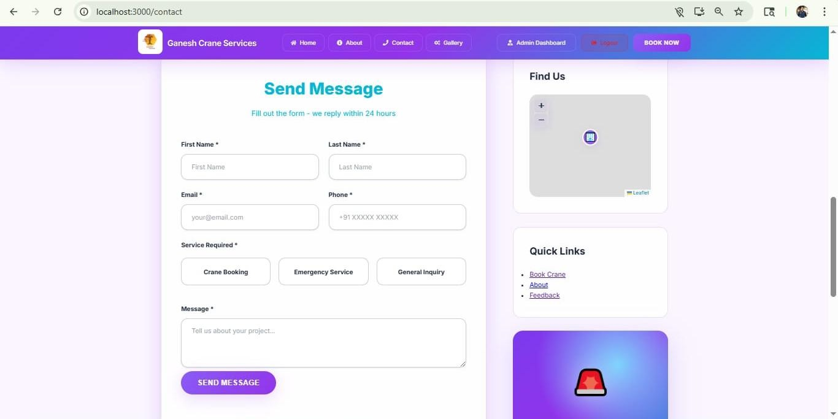

Fig 6.3 Contact Page Interface

The above diagram represents the Contact Page of the Ganesh Crane Service Management System. This interface allows users to communicate with the crane service provider by sending messages or service requests easily. It is designed to provide a simple and efficient way for customers to connect with the service team.

At the top of the page, a navigation bar is available with options such as Home, About, Contact, Gallery, Admin Dashboard, and Logout, along with a “Book Now” button. This helps users to navigate across different sections of the system without difficulty.

The main section contains a “Send Message” form where users can enter their details. The form includes fields such as First Name, Last Name, Email, Phone Number, and Service Required. The service options include Crane Booking, Emergency Service, and General Inquiry, allowing users to specify their requirements clearly. There is also a Message box where users can describe their needs or project details. After filling in the form, users can submit it using the “Send Message” button.

On the right side, a location map is provided under the “Find Us” section, which helps users identify the physical location of the crane service provider. Below that, Quick Links are available for easy navigation to important sections such as booking, about, and feedback.

Overall, this interface enhances communication between customers and the service provider by providing an easy-to-use contact form, location details, and quick navigation options, ensuring better customer support and service management.

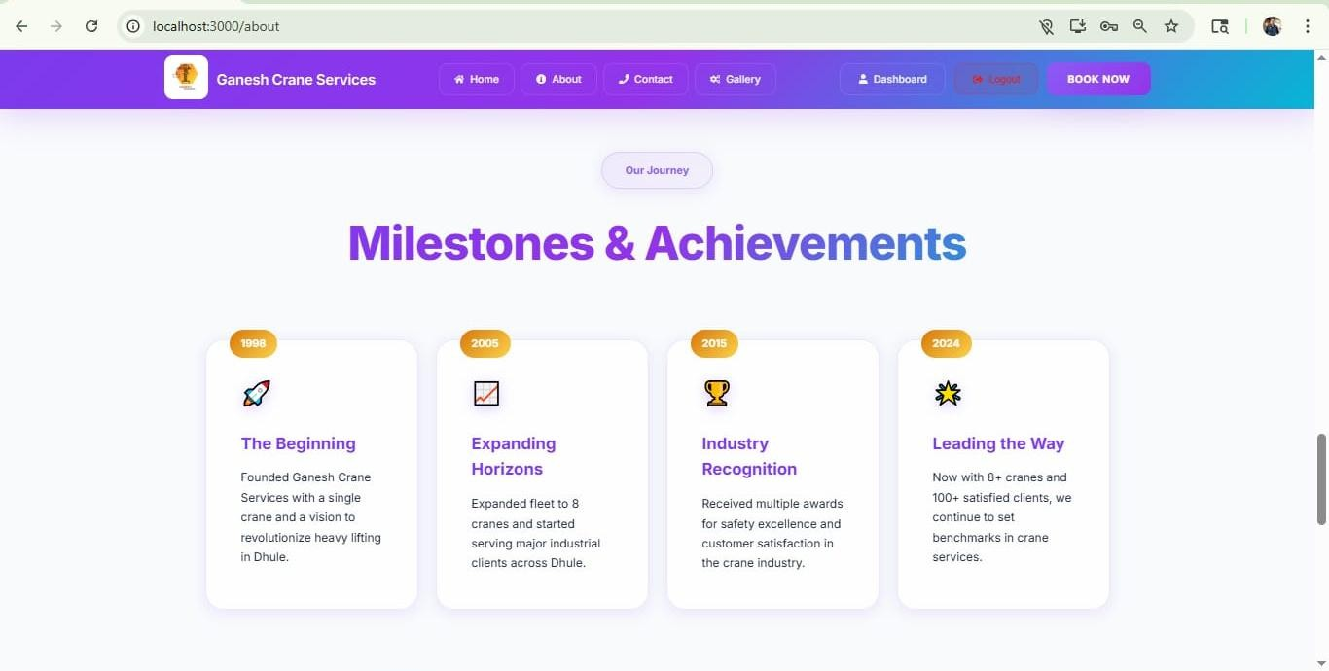

Fig 6.4 Milestone & Achievement Interface

The above diagram represents the About Page (Milestones & Achievements section) of the Ganesh Crane Service Management System. This interface showcases the journey, growth, and success of the crane service company over the years. It helps users understand the company’s background, achievements, and industry progress in a clear and visually appealing way.

At the top of the page, a navigation bar is available with options such as Home, About, Contact, Gallery, Dashboard, and Logout, along with a “Book Now” button. This allows users to easily navigate through different sections of the system and quickly access crane booking services.

The main section highlights the “Our Journey” heading followed by the title “Milestones & Achievements”, which presents the company’s timeline in a structured card format.

Each card represents a specific year and achievement:
1998 – The Beginning:
Ganesh Crane Services was founded with a single crane and a vision to improve heavy lifting services in Dhule.

2005 – Expanding Horizons:
The company expanded its fleet to multiple cranes and began serving major industrial clients.

2015 – Industry Recognition:
The company received awards for safety standards and customer satisfaction in the crane service industry.

2024 – Leading the Way:
With 8+ cranes and 100+ satisfied clients, the company continues to grow and set benchmarks in crane services.
Each milestone is displayed using icons, titles, and descriptions, making the information easy to understand and visually engaging.

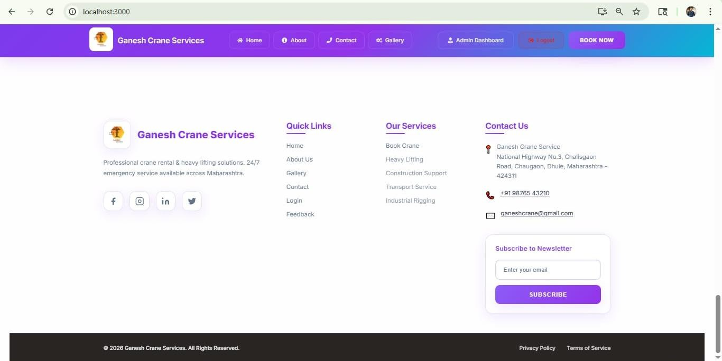

Fig 6.5 Footer Interface

The above diagram shows the footer area of the Ganesh Crane Services web application. This section appears at the bottom of the webpage and provides important information and quick navigation options for users.

At the top of the footer, the website branding “Ganesh Crane Services” is displayed along with a short description stating that the company offers reliable crane rental services 24/7. Social media icons (such as Facebook, Instagram, LinkedIn, and Twitter) are also provided so users can connect with the company online.

The footer is divided into multiple sections:
- Quick Links
This section provides easy navigation links to important pages such as:
  - Home
  - About
  - Gallery
  - Contact
  - Login
  - Feedback
These links help users quickly access different parts of the website without scrolling back to the top.

Our Services
This section lists the main services offered by the company, including:
  - Boom Crane
  - Heavy Lifting
  - Construction Support
  - Transport Service
  - Industrial Rigging
It gives users a quick overview of what services are available.

Contact Us
This section displays the company’s contact details such as:
  - Office address
  - Phone number
  - Email ID

This helps customers easily reach out for inquiries or service bookings.

Newsletter Subscription
Users can enter their email address and subscribe to receive updates, offers, or service notifications from the company.

Bottom Bar
At the very bottom, there is:
  - Copyright information
  - Links like Privacy Policy and Terms of Service.

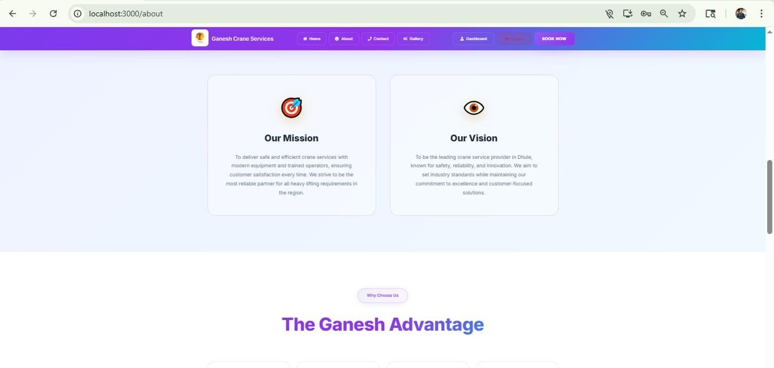

Fig 6.6 About Page Interface

This screenshot shows the About Page of your Ganesh Crane Services React application. At the top, there is a navigation bar with options like Home, About, Contact, Gallery, Dashboard, Logout, and a “Book Now” button for quick service booking.

In the main section, two cards are displayed:
Our Mission: Focuses on providing safe, efficient crane services with modern equipment and customer satisfaction.

Our Vision: Aims to become a leading crane service provider known for safety, reliability, and innovation.

Below that, a section titled “The Ganesh Advantage” highlights the key benefits or strengths of
the service.

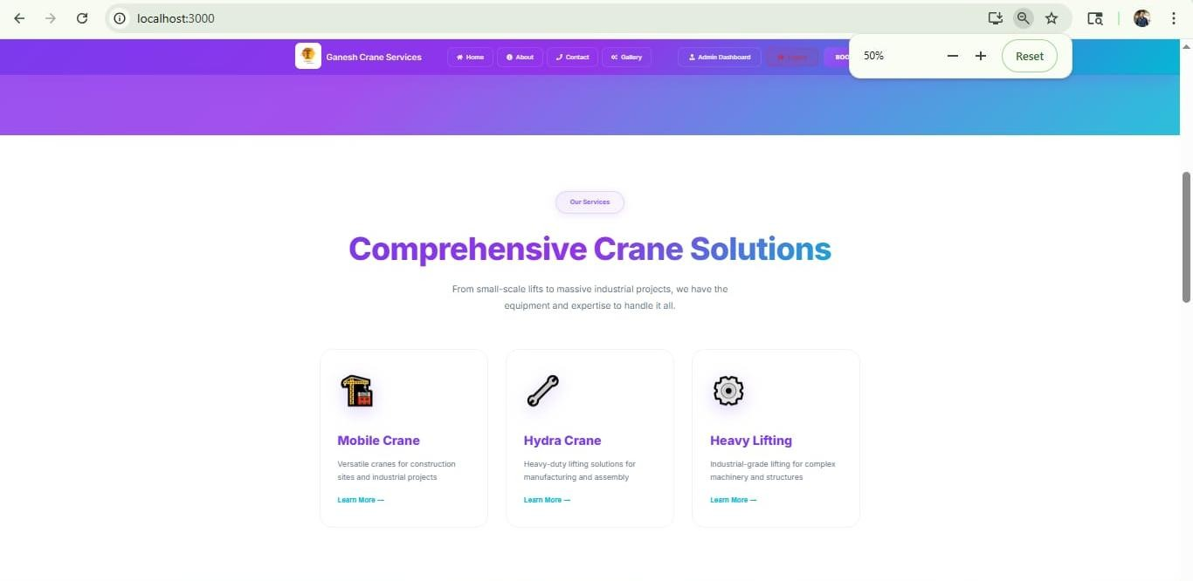

Fig 6.7 Service Section Interface

The above image represents the Home Page (Services Section) of the Ganesh Crane Service Management System. It is designed to showcase the different crane services provided to users in a clear and attractive way.

At the top, there is a navigation bar with options like Home, About, Services, Gallery, and Contact, along with a logo/title (“Ganesh Crane Services”). This helps users easily move between different sections of the website.

Below the navbar, there is a colorful gradient banner, which improves the visual appearance and gives a modern look to the page.

In the center, a main heading “Comprehensive Crane Solutions” is displayed. This heading highlights that the platform offers a wide range of crane-related services. A short description below it explains that the services are suitable for lifting, transportation, and heavy- duty work.

Further down, there are service cards that present different types of

crane services:
  - Mobile Crane – Used for flexible and easy movement at different locations
  - Hydra Crane – Suitable for quick lifting and transportation tasks
  - Heavy Lifting – Used for handling large and heavy materials
  - Each service card includes an icon, title, short description, and a “Learn More” link,
making it user-friendly and informative.
Overall, this page section is designed to inform users about available services, improve user experience, and help customers choose the right crane service easily.

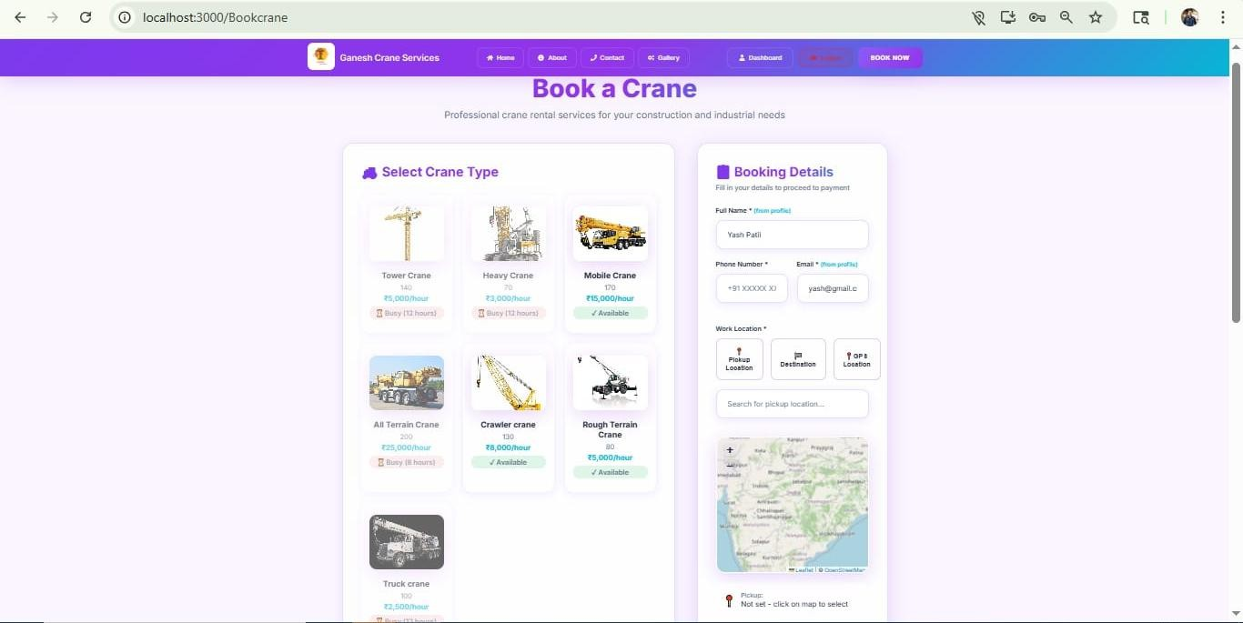

Fig 6.8 Crane Booking Interface

This screen represents the “Book a Crane” page of the Ganesh Crane Services Management System. It is designed to allow users to easily select a crane and submit booking details.

Header / Navigation Bar
At the top, there is a colorful navigation bar with options like:
  - Home, About, Contact, Gallery
  - Dashboard, Logout
  - A highlighted “BOOK NOW” button
This helps users quickly move between different sections of the website.

Page Title Section
The heading “Book a Crane” is displayed prominently.
A short description below explains that the service is for construction and industrial needs.

Crane Selection Section (Left Side)
Users can choose from different crane types such as:
  - Tower Crane
  - Heavy Crane
  - Mobile Crane
  - All Terrain Crane
  - Crawler Crane
  - Rough Terrain Crane
  - Truck Crane

Each crane card shows:
  - Image of the crane
  - Name and capacity
  - Price per hour (₹/hour)
  - Availability status (Available / Busy)
This section allows users to visually compare and select the required crane.

Booking Details Section (Right Side)
This is the form where users enter their details:
  - Full Name (auto-filled from profile)
  - Phone Number & Email
  - Work Location Options:
  - Pickup Location
  - Destination
  - GPS Location

  - A search box to enter location
  - An interactive map to select the exact pickup point This makes location selection easy and accurate.

Overall Functionality
  - User selects a crane from the left
  - Fills booking details on the right
  - Chooses location via map
  - Proceeds for booking/payment.

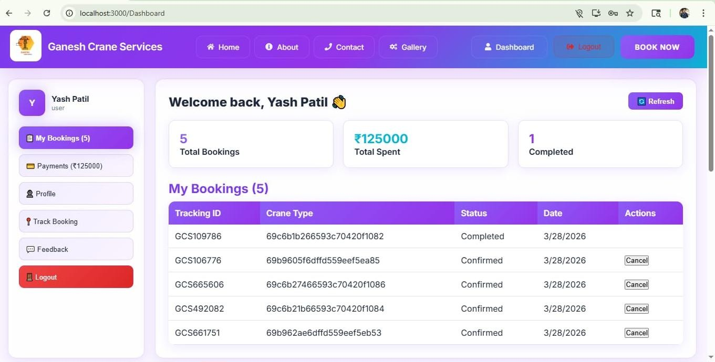

Fig 6.9 User Bookings Dashboard

This image shows the User Dashboard page of the Ganesh Crane Services Management System.
Here’s a clear explanation:

Overall Purpose
This page allows a logged-in user (customer) to view and manage their crane bookings, payments, and profile details in one place.

Top Navigation Bar
  - Contains menu options:
  - Home, About, Contact, Gallery, Dashboard

  - Logout button
  - Book Now button (to book a crane quickly) Helps users easily navigate through the system.

Left Sidebar Menu
  - Displays user name: Yash Patil
  - Menu options:
  - My Bookings (5) → shows total bookings
  - Payments (₹125000) → total money spent
  - Profile
  - Track Booking
  - Feedback
  - Logout
Provides quick access to different user features.

Dashboard Summary (Top Cards) Shows key statistics:
  - Total Bookings: 5
  - Total Spent: ₹125000
  - Completed: 1
These cards give a quick overview of user activity.

My Bookings Section
This is the main table where all bookings are listed.

Columns:
  - Tracking ID → unique ID for each booking
  - Crane Type → type/model of crane booked
  - Status → booking status (Completed / Confirmed)
  - Date → booking date
  - Actions → option to cancel booking

Example:
  - Some bookings are Confirmed
  - One booking is Completed
  - Users can cancel active bookings

Extra Feature
  - Refresh button → updates booking data

Conclusion
This dashboard is designed to:
  - Track bookings
  - View spending
  - Manage user activities
  - Cancel bookings easily.

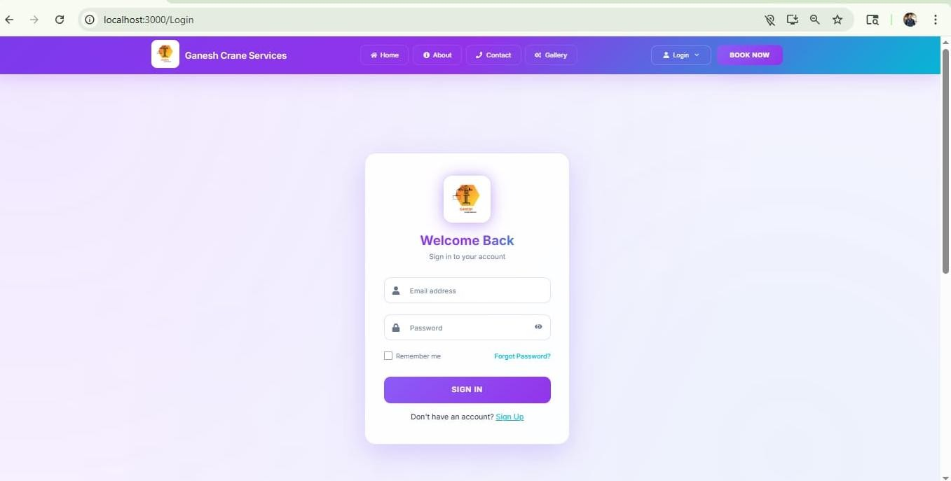

Fig 6.10 Admin Login Interface

The above diagram represents the Admin Login Page of the Ganesh Crane Service Management System. This interface allows administrators to securely access the system dashboard to manage crane bookings, users, and overall operations. It is designed with a clean and modern layout to ensure easy and secure login functionality.

At the top of the page, a navigation bar is available with options such as Home, About, Contact, Gallery, Login, and a “Book Now” button. This helps users navigate across different sections of the website while keeping the booking option easily accessible.

The main section displays a centered login card titled “Admin Portal”, along with a short description prompting admins to sign in. It includes input fields for Admin Email and Password, ensuring secure credential entry. There is also a “Remember me” option for convenience and a password visibility toggle icon for better usability.

Below the input fields, a prominent “ADMIN SIGN IN” button is provided to initiate the login process. Additionally, a “Back to User Login” link allows switching to the user login page.
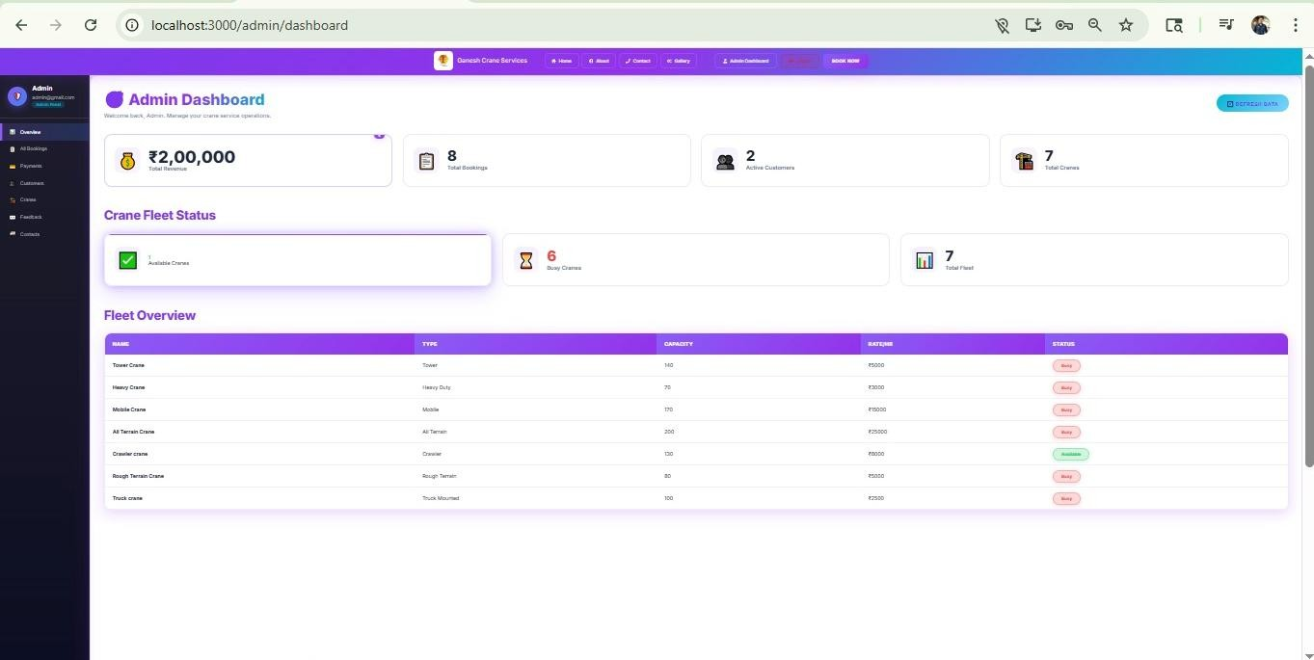

Fig 6.11 Admin Dashboard Interface

The above diagram represents the Admin Dashboard Page of the Ganesh Crane Service Management System. This interface provides a centralized overview for administrators to monitor and manage crane operations, bookings, customers, and fleet status efficiently.

At the top of the page, a navigation bar is available with options such as Home, About, Contact, Gallery, Admin Dashboard, and a “Book Now” button. This ensures smooth navigation across the system while keeping important actions easily accessible.

On the left side, a sidebar menu is displayed with sections like Overview, All Bookings, Payments, Customers, Cranes, Feedback, and Contacts, allowing admins to quickly access different management modules.

The main dashboard section starts with summary cards displaying key statistics such as Total Revenue (₹2,00,000), Total Bookings (8), Active Customers (2), and Total Cranes (7). These cards give a quick snapshot of business performance.

Below that, the Crane Fleet Status section highlights operational details, showing Available Cranes (1), Busy Cranes (6), and Total Fleet (7), helping admins track resource availability in real time.

Further down, the Fleet Overview table presents detailed information about each crane, including Name, Type, Capacity, Rate per hour, and Status (Available/Busy). This structured table allows administrators to monitor individual crane details and make informed decisions.
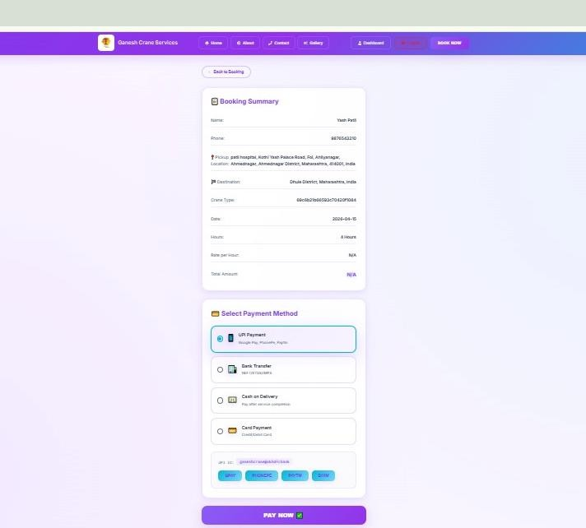

Fig 6.12 Payment Page Interface

The above diagram represents the Payment Page of the Ganesh Crane Service Management System. This interface allows users to review their booking details and complete the payment process securely using multiple payment options.

At the top of the page, a navigation bar is available with options such as Home, About, Contact, Gallery, Dashboard, Logout, and a “Book Now” button. This ensures smooth navigation while keeping important actions easily accessible.

The main section is divided into two key parts. The first part displays the Booking Summary, which includes important details such as Customer Name, Phone Number, Pickup
Location, Destination, Crane Type, Date, Working Hours, Rate per Hour, and Total Amount. This helps users verify all booking information before proceeding with the payment.

Below that, the Select Payment Method section provides multiple payment options such as UPI Payment (Google Pay, PhonePe, Paytm), Bank Transfer (NEFT/RTGS/IMPS), Cash on Delivery, and Card Payment (Credit/Debit Card). The selected option is highlighted for better user experience.

Additionally, for UPI payments, a UPI ID is displayed along with quick payment buttons, making the transaction process fast and convenient
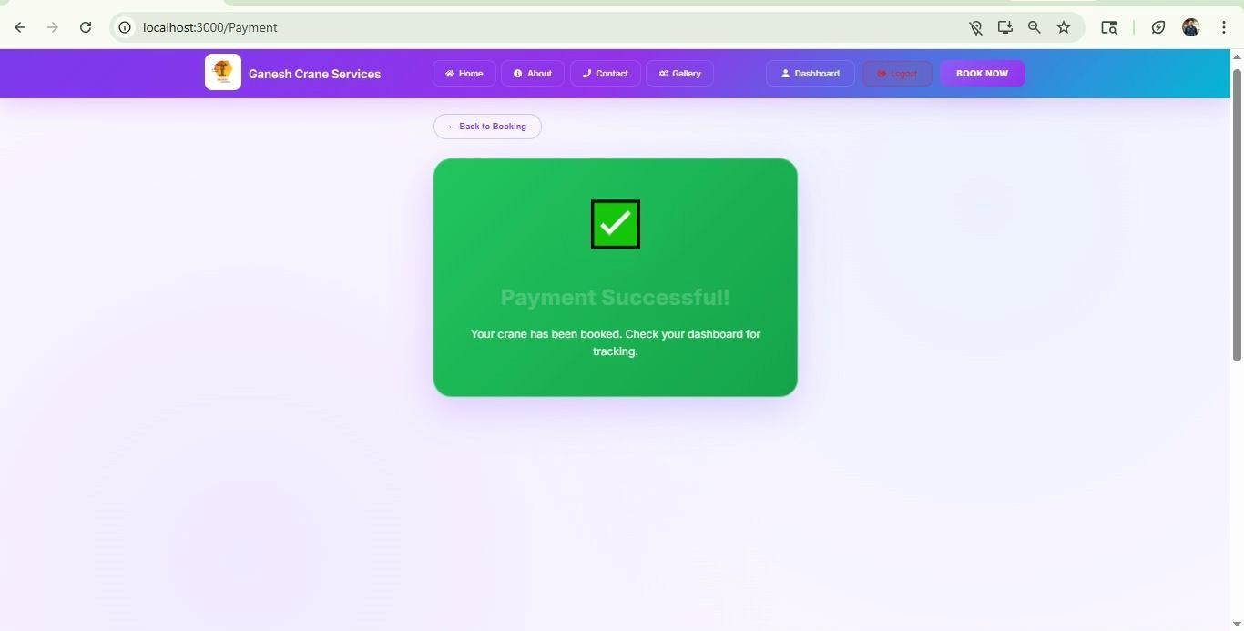

Fig 6.13 Payment Success Interface
The above diagram represents the Payment Success Page of the Ganesh Crane Service Management System. This interface confirms that the user’s payment has been completed successfully and the crane booking has been confirmed.

At the top of the page, a navigation bar is available with options such as Home, About, Contact, Gallery, Dashboard, Logout, and a “Book Now” button. This allows users to easily navigate to other sections of the system after completing their transaction.

The main section prominently displays a green confirmation card with a checkmark icon, indicating a successful transaction. It includes the message “Payment Successful!”,
followed by a short note informing the user that their crane has been booked successfully and they can check their dashboard for tracking details.

A “Back to Booking” button is also provided at the top, allowing users to return and make another booking if needed. The above diagram represents the All Bookings Page (Admin Panel).

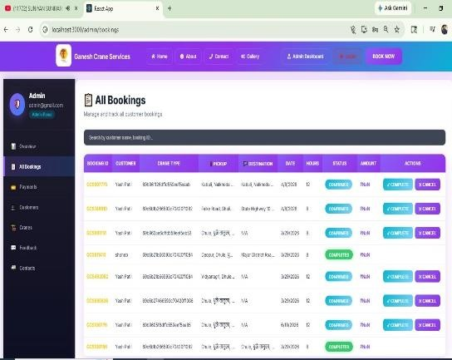

Fig 6.14 All Bookings Interface

Ganesh Crane Service Management System. This interface allows administrators to view, manage, and control all customer bookings in a structured and efficient manner.

At the top of the page, a navigation bar is available with options such as Home, About, Contact, Gallery, Admin Dashboard, Logout, and a “Book Now” button. This ensures smooth navigation across different modules of the system.

On the left side, a sidebar is displayed showing admin details (Admin name and email) along with menu options like Overview, All Bookings, Payments, Customers, Cranes, Feedback, and Contacts. The “All Bookings” section is highlighted, indicating the current active page.

The main section starts with the heading “All Bookings” and a short description “Manage and track all customer bookings”. Below this, a search bar is provided, allowing admins to quickly find bookings using customer name or booking ID, improving efficiency when handling large data.

A detailed bookings table is displayed, containing important columns such as:
- Booking ID – Unique identifier for each booking
- Customer Name – Name of the user who booked the crane
- Crane Type – Type or ID of the selected crane
- Pickup & Destination – Locations for the service
- Date & Hours – Booking schedule and duration
- Status – Current state (e.g., Confirmed, Completed)
- Amount – Total payment (some values may show pending/NaN)
- Actions – Buttons for managing bookings

Each row represents an individual booking, and the status is visually highlighted (e.g., blue for Confirmed, green for Completed) for quick identification.

On the right side of each row, action buttons such as “Complete” and “Cancel” are provided. These allow the admin to update the booking status based on service progress.

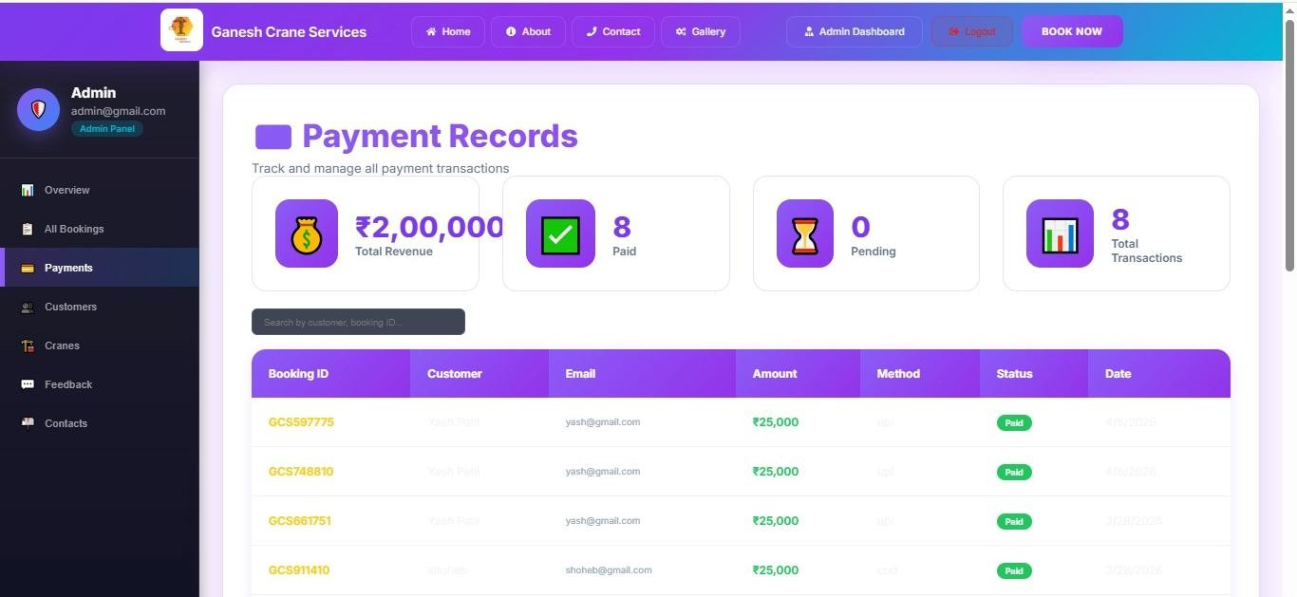

Fig 6.15 Payment Records Interface

The above diagram represents the Payment Records Page (Admin Panel) of the Ganesh Crane Service Management System. This interface allows administrators to track, monitor, and manage all payment transactions in a clear and organized manner.

At the top of the page, a navigation bar is available with options such as Home, About, Contact, Gallery, Admin Dashboard, Logout, and a “Book Now” button, ensuring easy navigation across the system.

On the left side, a sidebar is displayed showing admin details (name and email) along with menu options like Overview, All Bookings, Payments, Customers, Cranes, Feedback, and Contacts. The “Payments” section is highlighted, indicating the current active page.

The main section begins with the heading “Payment Records” along with a short description “Track and manage all payment transactions”. Below this, summary cards provide a quick overview of financial data, including:

- Total Revenue (₹2,00,000) – overall earnings
- Paid Transactions (8) – number of completed payments
- Pending Payments (0) – payments yet to be completed
- Total Transactions (8) – total number of payment records

A search bar is also provided to quickly find payment records using customer name or booking ID, improving efficiency.

Below the summary, a detailed payment table is displayed with columns such as:
- Booking ID – Unique identifier for each booking
- Customer Name – Name of the user
- Email – Customer’s email address
- Amount – Payment amount (e.g., ₹25,000)
- Payment Method – Mode of payment (UPI, COD, etc.)
- Status – Payment status (e.g., Paid)
- Date – Transaction date

Each row represents a single payment record, with the status visually highlighted (green for Paid) for quick identification.

Chapter 7 Testing

In this phase, we cover the overall process of validating the functionality and performance of the Ganesh Crane Service Management System. It includes the test plan that defines the testing strategy and scope, along with the execution of test cases for various scenarios such as booking management, crane allocation, customer handling, scheduling, and billing. Automated testing using Selenium is performed to improve efficiency, accuracy, and reduce manual effort. This phase also includes the test summary report to present overall testing results and the defect report to identify, track, and resolve issues effectively, ensuring the system operates smoothly and reliably.

Table 7.1 Test Plan

Section | Details
Test Plan ID | TP-GCSMS-01
Project Name | Ganesh Crane Service Management System
Objective | To verify that the system functions works correctly, efficiently, and reliably including booking management, crane allocation, customer handling, billing, and report generation.
Scope - In | User authentication, admin panel, customer management, crane management, booking system, service scheduling, billing & invoice  generation, payment tracking, reports, dashboard.
Scope - Out | Mobile application testing, Third-party payment gateway testing,  Multi-branch integration
Test Steps | Login (Admin/Staff/User) Add customer details  Add crane details Create booking request  Assign crane & schedule service

Section | Details
Test Approach | Functional Testing, Positive & Negative Testing, Data Validation  Testing, UI/UX Testing, Performance Testing, Security Testing
Entry Criteria | All modules developed, test environment setup complete, test cases  reviewed and approved, required test data available
Exit Criteria | All test cases executed successfully, major defects resolved, no  critical/blocker issues remaining, test reports generated
Test Environment | OS: Windows 11 Browser: Chrome, Firefox Database: MangoDB Server: Localhost  Tools: VS Code
Roles & Responsibilities | QA Lead: Approves test plan  Tester: Executes test cases and reports bugs Developer: Fixes issues and updates system  Project Guide: Reviews and gives final approval
Risks | System downtime, Data inconsistency, Booking conflicts, Calculation errors in billing, Network issues, Browser compatibility  issues

A test case is a defined scenario used to verify that a specific feature or functionality of the Ganesh Crane Service Management System works as expected. It includes inputs, execution steps, and expected outcomes for operations such as customer management, crane booking, service scheduling, billing, and report generation. Test cases help testers systematically validate the system and identify any errors or defects, ensuring smooth and reliable performance of the application.

Test Cases Execution for login :-

Table 7.2 Execution for login

Test Case ID | Objective | Steps / Input | Expected Output | Actual Output | Status
T- LOGIN-  01 | Login with valid user  credentials | Username: yash@gmail.com  Password: yash@123 | User should login  successfully | User logged in | Pass
T-  LOGIN- 02 | Login with  valid admin credentials | Username:  admin@gmail.com Password: admin123 | Admin should  login successfully | Admin  logged in successfully | Pass
T-  LOGIN- 03 | Login with  invalid username | Username: ABC Password: yash@123 | Error: "Invalid username" | Error displayed | Pass
T- LOGIN-  04 | Login with invalid  password | Username: yash@gmail.com  Password: 1234 | Error: "Invalid password" | Error displayed | Pass
T-  LOGIN- 05 | Login with  empty username | Username: blank Password: yash@123 | Error:  "Username required" | Error displayed | Pass
T- LOGIN-  06 | Login with empty  password | Username: yash@gmail.com  Password: blank | Error: "Password  required" | Error displayed | Pass
T- LOGIN- 07 | Switch between admin &  User | Click Admin → User | Role should switch and UI update | Works correctly | Pass
T- LOGIN-  08 | Show/Hide password | Click eye icon | Password should toggle  visibility | Works correctly | Pass
T-  LOGIN- 09 | Login with  uppercase username | Username:  YASH@gmail.com Password: 12345678 | System should  reject if case- sensitive | Login failed as expected | Pass

T- LOGIN- 10 | Logout functionality | Click logout button | User should be logged out and redirected to  login page | User logged out successfully | Pass
T- LOGIN- 11 | Reset password with invalid  key | Username: admin, wrong key | Error: "Invalid reset key" | Error displayed | Pass
T-  LOGIN- 12 | Reset  password mismatch | New: pass123 Confirm: pass1234 | Error:  "Passwords do not match" | Error displayed | Pass
T- LOGIN- 13 | Session handling after browser  close | Login → close browser  → reopen | User should be logged out (session expired) | User logged out correctly after reopening | Pass
T-  LOGIN- 14 | Weak  password validation | New pass: 12345678 | System should  reject weak password | Weak  password rejected | Pass
T- LOGIN- 15 | XSS  validation | Enter  <script>alert('XSS')  </script> | Script should be sanitized/block  ed | Script stored in DB | Fail

Automated Testing:
Selenium is an open-source automation testing tool used for testing web applications. It allows testers to automate browser actions such as entering data, clicking buttons, and validating outputs, simulating real user interactions. Selenium supports multiple programming languages and browsers, making it widely used for functional and regression testing.
A total of 1 test case were executed for the Login Module, out of which 1 test case passed successfully.
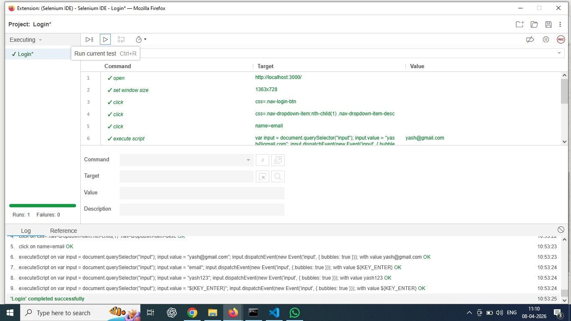

Fig 7.1 Login Module Test Summary

This image shows the execution of the login module test cases using Selenium IDE in the Ganesh Crane Service Management System. The interface displays a sequence of automated commands such as opening the application on localhost, setting the browser window size, clicking on login options, and entering user credentials like email and password. Each step is executed successfully, as indicated by the “OK” status in the log section. The automation script simulates real user actions and verifies the correct functioning of the login process. The final message “Login completed successfully” confirms that the test case has passed, demonstrating that the login functionality is working correctly and efficiently.

Test Summary Report:
A test summary provides an overall evaluation of the testing process and its outcomes for the Ganesh Crane Service Management System. It includes details such as the total number of test cases executed, passed, and failed, along with key findings and identified defects. This summary helps in assessing the system quality and determining its readiness for deployment.

Test Summary Report – Login Module

Test Summary Report Identifier:
TSR-LOGIN-2026-01 – Unique ID for the test summary report.

- Summary:
Testing of the Login Module verified functionalities such as user authentication, input validation, error handling, password visibility toggle, role switching, and logout functionality. Various test cases including valid, invalid, and security scenarios were executed to ensure proper system behaviour.

Variances:
All test cases were executed as per the plan. However, additional time was required to test security aspects such as input validation for potential vulnerabilities.

Comprehensiveness:
Complete test coverage was achieved for all login-related functionalities including positive scenarios, negative scenarios, and security validation checks.

Results:
Out of total test cases executed:
  - 14 test cases passed successfully
  - 1 test case failed (XSS vulnerability)
The failed test case has been logged as a defect for further resolution.

Evaluation:
The Login Module is functionally stable and performs as expected for most scenarios. However, a critical security issue related to XSS vulnerability must be resolved before deployment.

Activities:
Activities performed include requirement analysis, test case design, test environment setup, execution of test cases, validation testing, security testing, and browser compatibility testing.

Approvals:
The module is reviewed and approved by the Test Lead and QA Team for further improvements and final deployment after fixing the identified defect.

Defect Report:-
A defect report is a document used to record and track issues identified during testing. It includes details such as defect description, steps to reproduce, expected and actual results, severity, priority, and status. This helps developers understand, fix, and monitor defects effectively, ensuring improved system quality.

Table 7.3 Defect Report for Login

Field | Details
Defect ID | DEF-LOGIN-01
Defect Title | XSS vulnerability in username/Email input field
Module Name | Login Module
Test Case ID | T-LOGIN-01
Reported By | Tester
Reported Date | 08-Apr-2026
Assigned To | Developer
Priority | High

Severity | Critical
Field | Details
Status | Open
Environment | Windows 11, Chrome, Localhost
Description | The login module allows execution or storage of malicious scripts entered in the username/email field, leading to a Cross- Site Scripting (XSS) vulnerability.
Precondition | User accesses login form
Steps to Reproduce | - Enter <script>alert('XSS')</script> in username/Email field  - Click on login button
Expected Result | The system should validate and sanitize input, preventing script execution.
Actual Result | Script is accepted and stored, causing a security vulnerability.
Frequency | Always
Severity Justification | Can allow attackers to inject malicious scripts, leading to data theft or unauthorized access.
Priority Justification | Immediate fix required due to high security risk.

Chapter 8

Conclusion and Future scope

Conclusion :-

In conclusion, the Ganesh Crane Service Management System provides an efficient and user-friendly platform for managing crane service operations and related activities. The system enables clients, operators, staff, and administrators to interact in a structured manner and perform their respective tasks effectively.

By digitizing service records, booking details, and operational data, the system reduces manual work, minimizes errors, and ensures accurate data management. It allows clients to easily book crane services, track job status, and maintain proper service records. Operators and staff can efficiently manage work assignments, update service details, and monitor ongoing tasks.

Overall, the system improves service management, ensures timely crane operations, and provides a reliable solution for maintaining records in an organized and systematic way.

Future Scope

- The system can be expanded for use in all over India.
- Multi-language support can be added to make the system accessible in different regional languages.
- A mobile application (Android/iOS) can be developed for better accessibility and real- time updates.
- SMS and email notification systems can be integrated for booking confirmations and service updates.
- Integration with GPS tracking systems for real-time crane location monitoring.
- Cloud-based storage can be implemented for better data security and scalability.
- AI-based analytics can be added for demand prediction, maintenance scheduling, and performance analysis.

Chapter 9

References and Bibliography

References:-
Crane service provider with whom we discussed for requirements and understanding of crane operations:
  - Rakesh Sunil Jadhav (Owner – Ganesh Crane Service)
  - Pramod Nana Khatal Crane Operators and Worker (Ganesh Crane Service)
  - Ritesh Sanjay Bhil Crane Operators and Worker (Ganesh Crane Service)

Local Customers using crane services
  - Rajashree Steel Industries Pvt. Ltd Avdhan MIDC, Dhule
  - Deore Brother’s Construction Dhule

Applications / Systems Referred:
- Crane Finder Application – The Liebherr Group Developed This App

Books / Study Material:
  - Construction Equipment Management – K.K. Chitkara
  - Principles of Construction Management – Roy Pilcher
  - Software Testing Principles and Practices – Srinivasan Desikan, Gopalswamy Ramesh

Bibliography:
  - For HTML, CSS, JavaScript concepts- https://www.w3schools.com
  - For React.js framework documentation- https://reactjs.org
  - For Node.js backend development- https://nodejs.org
  - For MongoDB database documentation- https://www.mongodb.com

